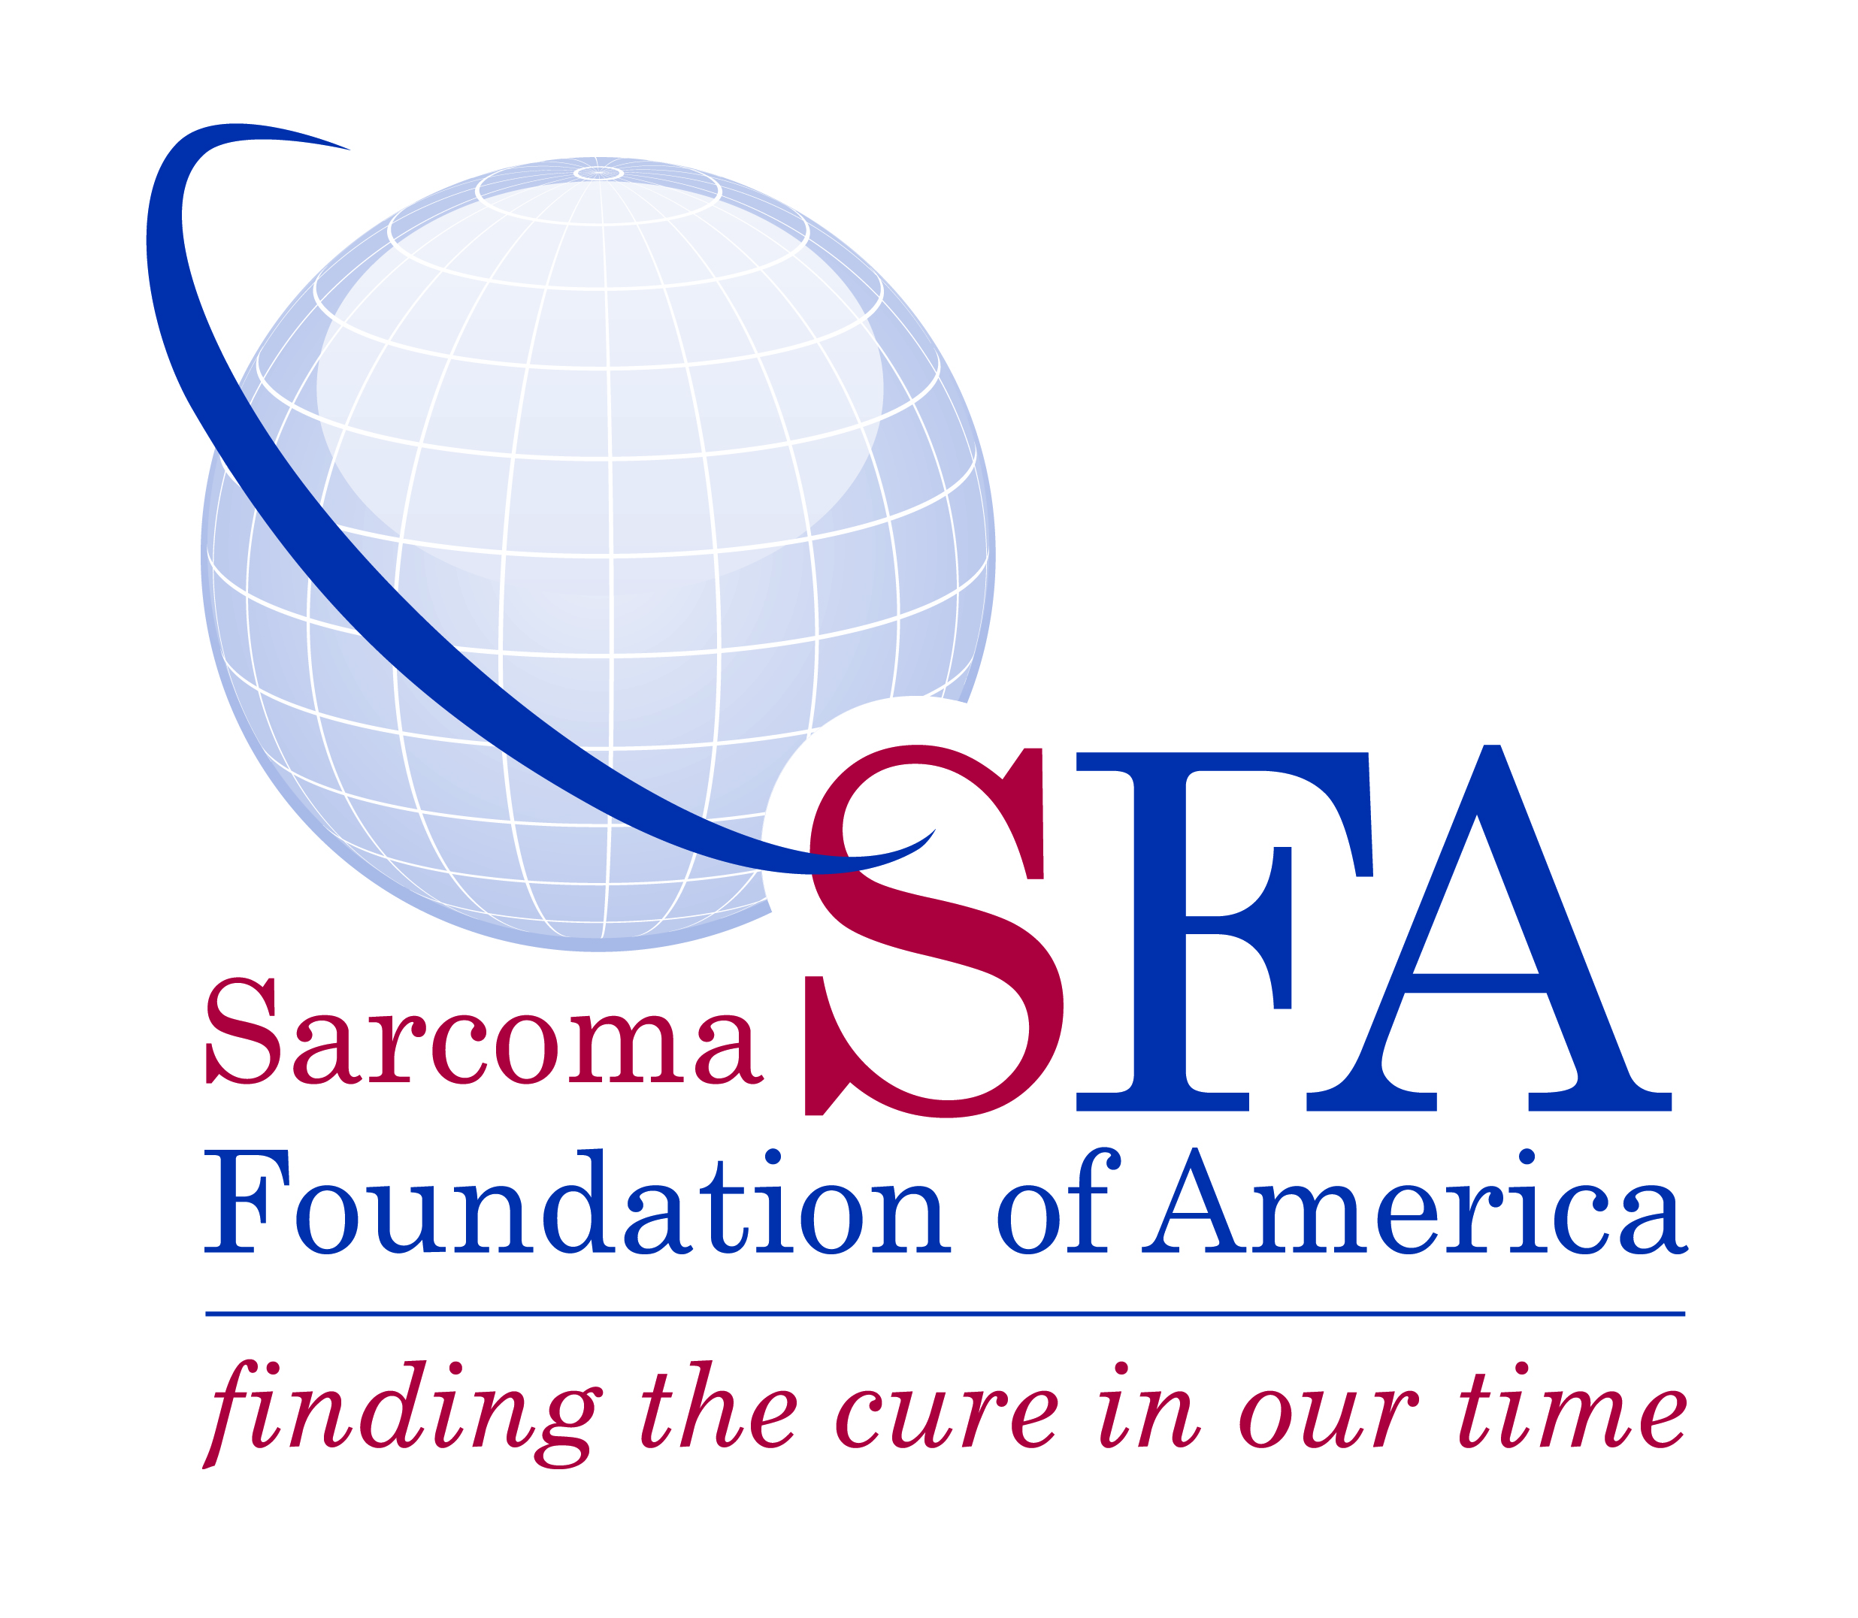
SARCOMA FOUNDATION OF AMERICA
www.curesarcoma.org

Contact: Elinore Tibbetts
301-253-8687, ext. 111
etibbetts@curesarcoma.org

New York Jets’ John Franklin-Myers Is Named Sarcoma Foundation of America Awareness Ambassador

Damascus, Md. December 8, 2022 – The Sarcoma Foundation of America (SFA), an organization dedicated to increasing research and awareness for sarcoma, announced today that New York Jets’ John Franklin-Myers will serve as SFA Awareness Ambassador.

Franklin-Myers has a personal connection to the sarcoma community. The defensive end supports SFA in memory of his grandfather Billy Ray-Myers who died of sarcoma in 2011. Franklin-Myers’ past support of SFA includes his participation in the National Football League’s My Cause, My Cleats program during which he had a pair of custom cleats designed to reflect his support of SFA and auctioned them to benefit the foundation. In addition, he formed a team to participate in the 2022 New Jersey Race for the Cure. Both activities successfully built awareness of SFA’s mission and assisted with raising funds for sarcoma research grants.

“Being the voice of SFA is huge. I also learned that many who work there have lost a loved one to sarcoma,” says Franklin-Myers. “I want to raise awareness, and this is the best way of going about it.”

“The Foundation is thrilled to continue working with John in this official capacity. His ability to spotlight the importance of research for a cure is invaluable,” says SFA Chief Executive Officer Brandi Felser. “John’s support of SFA is genuinely heartfelt and inspired by his desire to prevent other families from enduring the loss of a loved one to sarcoma.”

# # #

About the Sarcoma Foundation of America
The Sarcoma Foundation of America (SFA), a 501(c)(3) nonprofit charitable organization, is an advocate for increased research to find new and better therapies with which to treat patients with sarcoma. The organization raises money to privately fund grants for sarcoma researchers and conducts education and advocacy efforts on behalf of sarcoma patients. For more information, please visit www.curesarcoma.org.

About Sarcoma
Sarcoma is a rare cancer in adults (1 percent of all adult cancers) but rather prevalent in children (about 15% of all childhood cancers). At any one time, 50,000 patients and their families are struggling with sarcoma. Every year, nearly 16,000 new cases are diagnosed and more than 6,000 people die from the disease.

